# E-COMMERCE SALES ANALYSIS

A PROJECT REPORT SUBMITTED IN PARTIAL FULLFILLMENT OF THEREQUIREMENTSOF

BY

A.AMARNATH

[amaramar01614@gmail.com](mailto:anbuanbalagan273@gmail.com)

**au810021114007**

Undertheguidanceof

## P.Raja, Master Trainer

# ACKNOWLEDGEMENT

Wewouldliketotakethisopportunitytoexpressourdeepsenseofgratitudetoallindividuals who helped us directlyor indirectlyduringthis thesis work.Firstly, we would like to thank my supervisor**Dr.V.C.Sathish Gandhi, M.E, MBA, PH.D.**for being a great mentor and the best adviser I could ever have. His advice, encouragement andthecriticsareasourceofinnovativeideas,inspirationandcausesbehindthesuccessfulcompletionof this project. The confidence shown in me by him was the biggest source of inspiration for me.It has been a privilege working with him for the last one year. He always helped me during myprojectandmanyotheraspectsrelatedtotheprogram.Histalksandlessonsnotonlyhelpinprojectworkandotheractivities oftheprogrambutalsomakemeagoodandresponsibleprofessional.

ABSTRACTOF THEPROJECT

This project focuses on performing a comprehensive analysis of e-commerce sales datato uncover actionable insights and support data-driven decision-making for online retail businesses. The analysis involves multiple key components, starting with the exploration of historical sales data, customer behavior, and product performance to identify patterns and trends. We aim to assess the influence of factors such as pricing strategies, seasonal variations, promotional campaigns, and customer demographics on sales performance.

**The project utilizes advanced data preprocessing techniques to clean and transform raw data, followed by exploratory data analysis (EDA) to visualize trends and relationships among various factors. Predictive modeling approaches, including regression and classification algorithms, are employed to forecast future sales, predict demand for specific products, and segment customers based on purchasing behavior.**

**Key findings from the analysis will be presented, highlighting the most influential drivers of sales performance, including insights into product categories, customer segments, and seasonality effects. Furthermore, the study provides recommendations for optimizing marketing strategies, improving inventory management, and enhancing customer retention to drive revenue growth in the competitive e-commerce landscape.**

**This project leverages statistical analysis, machine learning models, and visualization techniques to generate insights that can guide e-commerce businesses toward improving their operational efficiency and maximizing profitability.**

**Key objectives, methods, and outcomes of the e-commerce sales analysis project, and how it will benefit businesses in making informed decisions**

# TABLEOFCONTENTS

## Chapter 1.IntroductionChapter2.Literature Review

**Chapter 3. Data Collection and Methodology**

**Chapter 4. E-Commerce Sales Trends Analysis**

**Chapter 5. Factors Influencing E-Commerce Sales**

**Chapter 6. Impact of Technology on E-Commerce Sales**

**Chapter 7. Challenges in E-Commerce Sales**

**Chapter 8. Case Studies and Industry Examples**

**Chapter 9. Recommendations**

**Chapter 10.Results and Discussion**

**Chapter 11. Conclusion**

# CHAPTER1

**Introduction**

### 1.1 Background and Importance of E-Commerce:The e-commerce industry has transformed the global economy by enabling businesses and consumers to conduct transactions anytime and anywhere. With the rise of digital technology, online shopping has become a preferred choice for consumers, leading to a rapidly expanding e-commerce sector that impacts nearly every industry worldwide. The significance of e-commerce extends beyond mere convenience; it also allows businesses to reach a broader audience, reduce operational costs, and utilize data for more precise targeting and customer personalization.

**1.2 Objectives of the Study:**Here, the specific goals of the analysis are outlined, such as identifying sales trends, understanding consumer behavior, and providing insights to optimize e-commerce strategies.

**1.3 Scope and Limitations:** This section defines the boundaries of the study (e.g., geographic focus, industry-specific analysis) and discusses any limitations or challenges encountered during the research.

### 1.4 Methodology Overview

This study employs a combination of statistical techniques and machine learning models to analyze e-commerce sales data. Key methodologies include:

* **Statistical Techniques**: Time-series analysis, correlation analysis, and regression modeling help identify trends, patterns, and relationships within the data.
* **Machine Learning Models**: Predictive algorithms such as decision trees, clustering, and association rule mining (for market basket analysis) are applied to enhance forecasting and identify customer segments.

**CHAPTER 2**

**Literature Review**

### 2.1 Trends in E-Commerce:The e-commerce industry is evolving rapidly, driven by advancements in technology, changing consumer preferences, and the increasing availability of internet access worldwide. This section explores some of the most significant trends in e-commerce, including the growth of online shopping, the shift towards mobile commerce, and the influence of omnichannel retailing.

**2.2 Factors Influencing Online Shopping Behavior:** This section examines factors like price sensitivity, product reviews, delivery options, and marketing tactics that influence consumer decisions.

**2.3 E-Commerce Growth and Market Dynamics:** A review of the overall growth trajectory of e-commerce and the changing competitive landscape, including the rise of major players like Amazon and Alibaba.

**2.4 Impact of Technology on E-Commerce Sales:** Explores how advancements in technology (such as AI, AR, and chatbots) are reshaping the way businesses interact with customers and boost sales.

### 2.5 Previous Research on E-Commerce Sales Analysis:The analysis of e-commerce sales has been the focus of extensive research across business and academic communities, driven by the need for insights into consumer behavior, product demand, and effective digital marketing strategies. Previous studies on e-commerce sales analysis have contributed valuable findings, particularly in areas such as customer segmentation, sales forecasting, product recommendation systems, and conversion rate optimization. This section summarizes key findings and methodologies from existing literature, which provide a foundation for the current analysis.

**CHAPTER 3**

**Data Collection and Methodology**

### .3.1 Data Sources:The data sources used for this e-commerce sales analysis encompass a variety of structured and unstructured data, providing a comprehensive view of sales trends, customer behavior, and website performance. Key data sources include:

### 3.2 Data Cleaning and Preprocessing:Data cleaning and preprocessing are crucial steps to ensure that the raw data is accurate, consistent, and suitable for analysis. These processes involve identifying and resolving errors, formatting inconsistencies, and standardizing data to allow meaningful insights to be drawn. Here’s a breakdown of the key steps in this process:

### ****Handling Missing Data****: Missing values are common in raw datasets and can be problematic for analysis. Techniques for addressing missing data include:

### ****Imputation****: Replacing missing values with the mean, median, or mode for numerical data, or with the most common category for categorical data. For instance, if a customer’s age is missing, it might be filled with the average age of similar customers.

**3.3 Analytical Tools and Techniques**: A description of the tools and methods used for analysis:

**3.3.1 Statistical Analysis:** Techniques like regression analysis, correlation analysis, or time series analysis to interpret sales data.

**3.3.2 Machine Learning Models**: If applicable, the use of machine learning algorithms for predictive modeling (e.g., sales forecasting, customer segmentation).

**3.4 Model Validation and Evaluation:** Describes how the models and analysis are validated (e.g., using cross-validation, performance metrics like accuracy, precision, etc.)

**CHAPTER 4**

1. **Commerce Sales Trends Analysis**

### 4.1 Overall Sales Growth and Forecasting:Analyzing overall sales growth and forecasting future performance are fundamental for understanding the trajectory of an e-commerce business and planning effectively for the future. This section evaluates the historical growth in sales over time and projects future trends based on the collected data.

### ****Overall Growth Analysis****: By examining sales data from previous years, we can identifykey trends in growth. Many e-commerce platforms have experienced a steady upward trend in revenue, largely due to increasing digital adoption, improved customer experience, and growing global internet access. However, growth rates can vary depending on external factors such as market conditions, competition, and consumer behavior shifts. For instance, many companies saw a surge in sales during the COVID-19 pandemic, as consumers shifted to online shopping.

**4.2 Seasonal and Temporal Trends:** Identifies patterns in sales based on time, such as peak shopping seasons (e.g., holiday sales), day-of-week effects, or trends tied to special events.

**4.3 Product Category Analysis:**Breaks down sales by product category to identify which categories are seeing the most demand and which are underperforming.

**4.3.1 High-Demand Products:** Highlights products with the strongest sales growth.

**4.3.2 Low-Demand Products:** Identifies products that are not selling well and may require marketing or strategy adjustments.

**4.4 Regional Sales Distribution**: Examines how sales are distributed across different geographic locations (regions, countries, cities) and any regional preferences or market gaps.

**CHAPTER 5**

**Factors Influencing E-Commerce Sales**

### 5.1 Behavior Analysis:Understanding consumer behavior is essential for optimizing e-commerce sales, as it reveals the motivations, preferences, and decision-making processes that drive purchasing patterns. Behavior analysis focuses on identifying how consumers interact with the e-commerce platform, what influences their buying decisions, and the common characteristics of purchasing habits.

### 5.2 The Role of Digital Marketing:Digital marketing is a crucial driver of e-commerce sales, as it allows businesses to reach, engage, and convert customers online. Various digital marketing strategies, such as social media marketing, search engine optimization (SEO), and pay-per-click (PPC) advertising, play distinct roles in promoting e-commerce products, building brand awareness, and driving traffic to online stores.

### ****Social Media Marketing****: Social media platforms, like Instagram, Facebook, and TikTok, are powerful tools for reaching large audiences, especially younger demographics who are frequent online shoppers. Social media marketing can include organic posts, influencer partnerships, and paid advertisements, each aimed at promoting products and creating brand loyalty. Visual platforms like Instagram are particularly effective for showcasing product aesthetics and lifestyle images, while influencer marketing leverages trusted figures to promote products authentically. Furthermore, features like shoppable posts enable users to purchase directly from social media, simplifying the shopping journey and driving sales.

**5.3 Pricing Strategies and Discounts:**Investigates the effects of pricing models on sales

volume.

**5.4 Impact of Customer Reviews and Ratings:** Explores how consumer feedback (reviews, ratings) influences purchasing decisions and product visibility.

**5.5 Website User Experience and Conversion Rates:**Examines how website design, navigation, and overall user experience affect conversion rates and sales performance.

**CHAPTER 6**

**Impact of Technology on E-Commerce Sales**

### 6.1 Mobile Commerce and Mobile Optionimizat:Mobile commerce, or m-commerce, has become a significant driver of e-commerce sales as more consumers shift to using mobile devices for online shopping. With the increase in smartphone and tablet usage, mobile commerce now represents a substantial portion of total e-commerce revenue. This trend underscores the need for e-commerce businesses to prioritize mobile optimization to ensure seamless user experiences and maximize sales potential.

**The Rise of Mobile Commerce**: Mobile commerce allows consumers to shop anytime and anywhere, providing unparalleled convenience. Many e-commerce companies report that a majority of their traffic and sales now come from mobile devices, reflecting changing consumer behavior. Factors contributing to the rise of mobile commerce include the convenience of shopping on-the-go, improved mobile technology, and the growing use of digital wallets that simplify the checkout process.

**6.2 The Role of Artificial Intelligence and Chatbots:** Discusses how AI and chatbots improve customer service, personalization, and sales efficiency.

**6.3 Augmented Reality (AR) and Virtual Try-Ons:** Highlights the use of AR technology in e-commerce, such as virtual fitting rooms or interactive product demos.

**6.4 Blockchain and E-Commerce Security:** Explores how blockchain technology is improving security, transparency, and trust in online transactions.

**6.5 Payment Systems and Digital Wallets:** Examines the growth of alternative payment methods (e.g., Apple Pay, cryptocurrency) and their impact on customer convenience and sales.

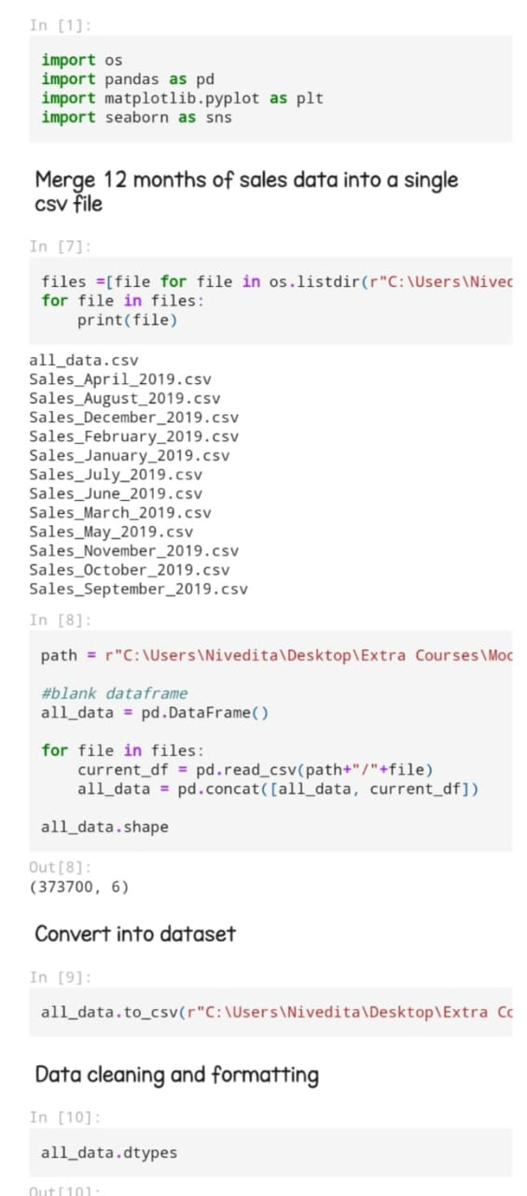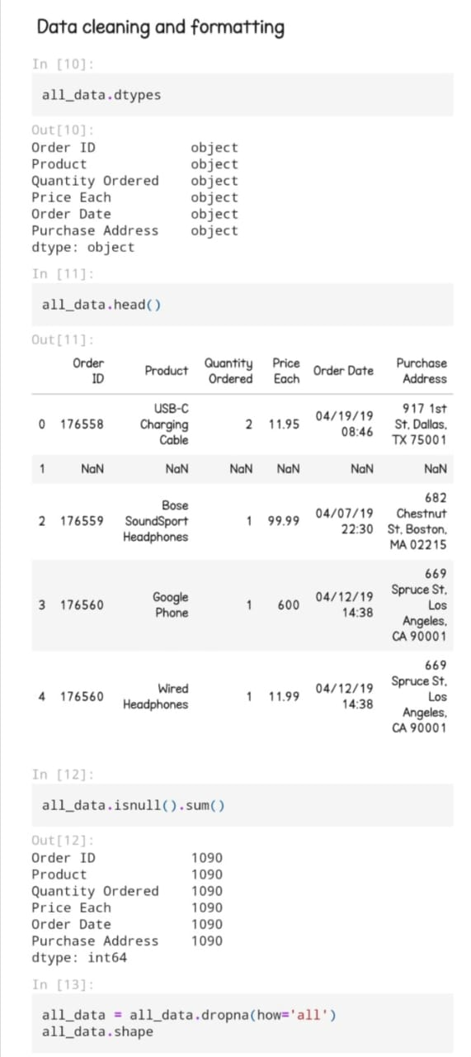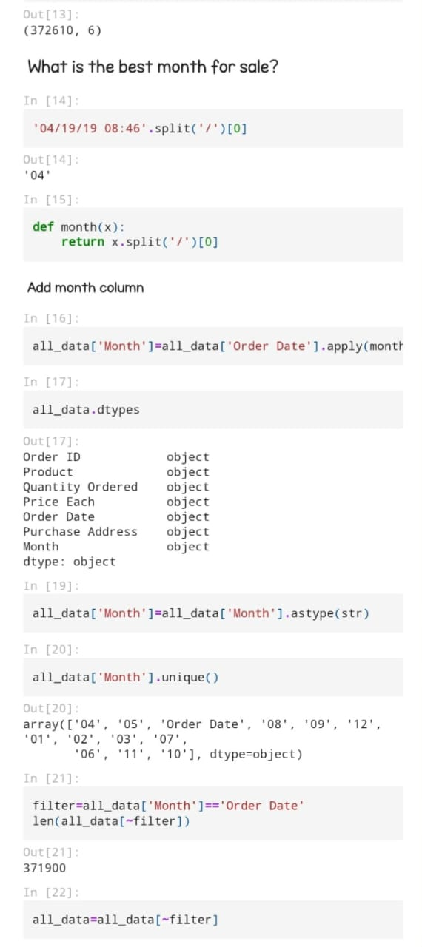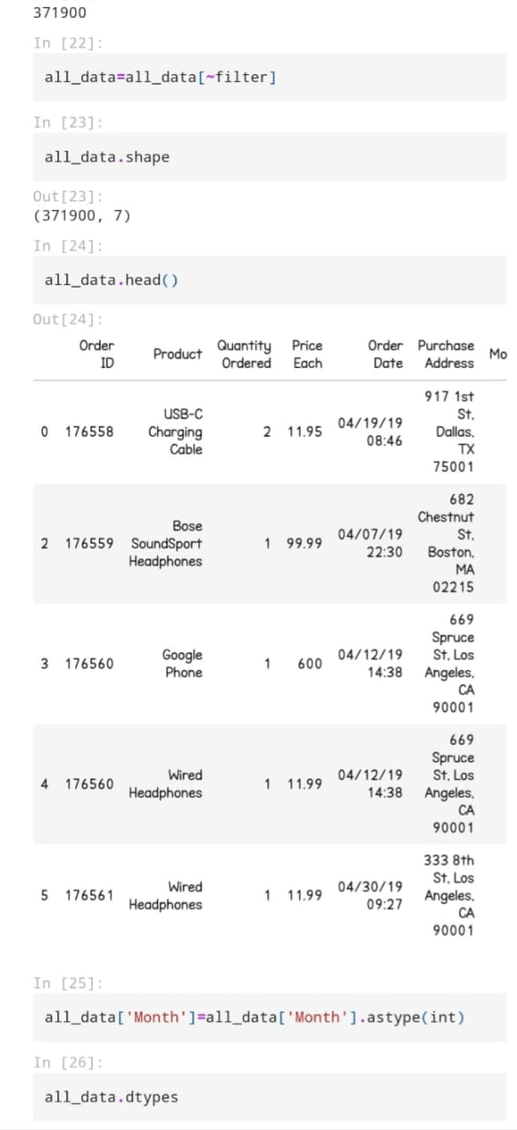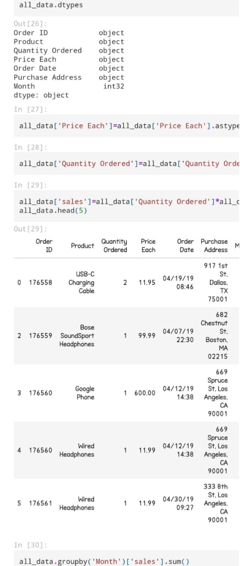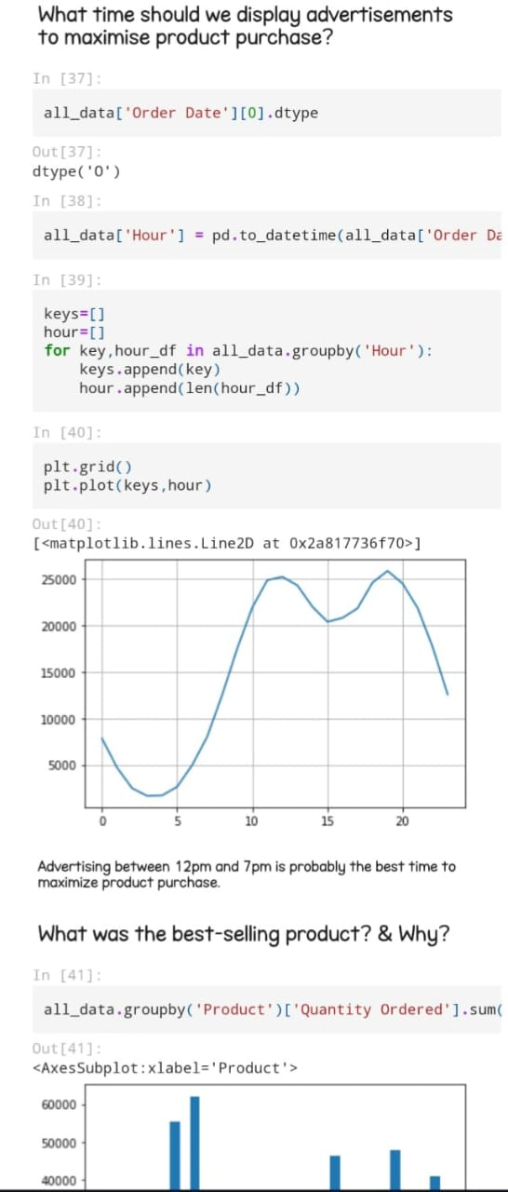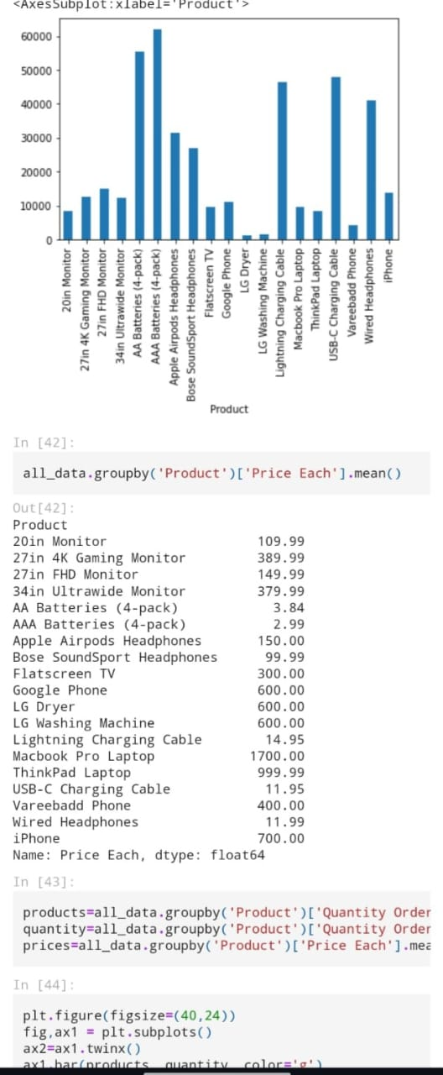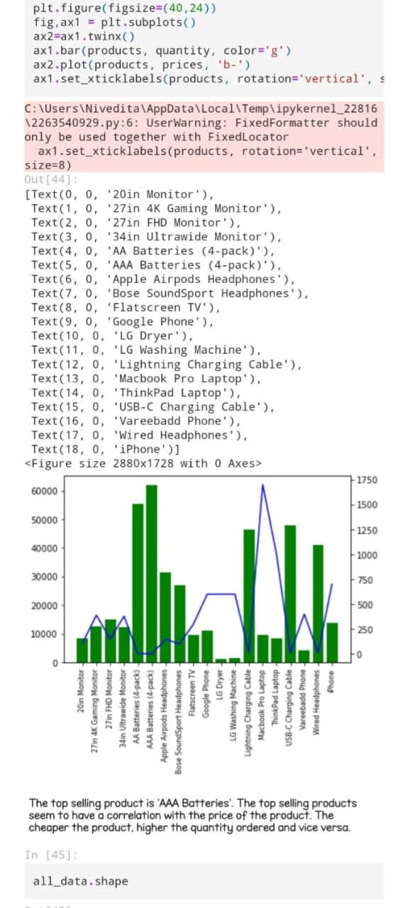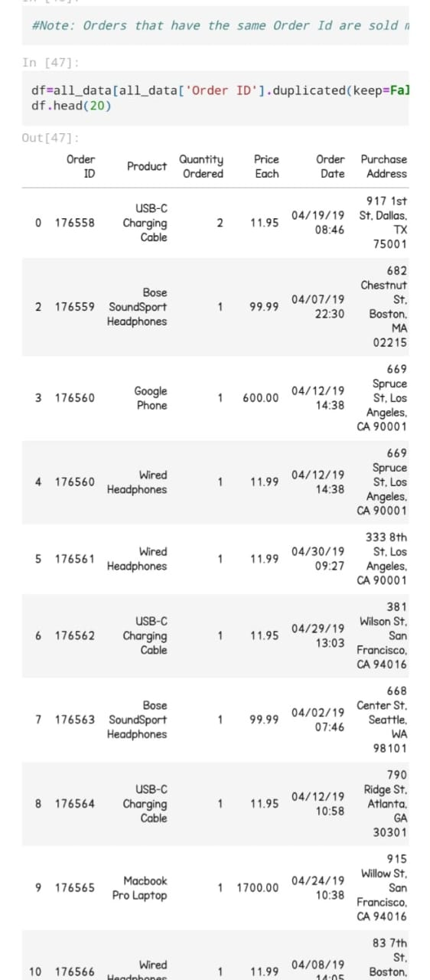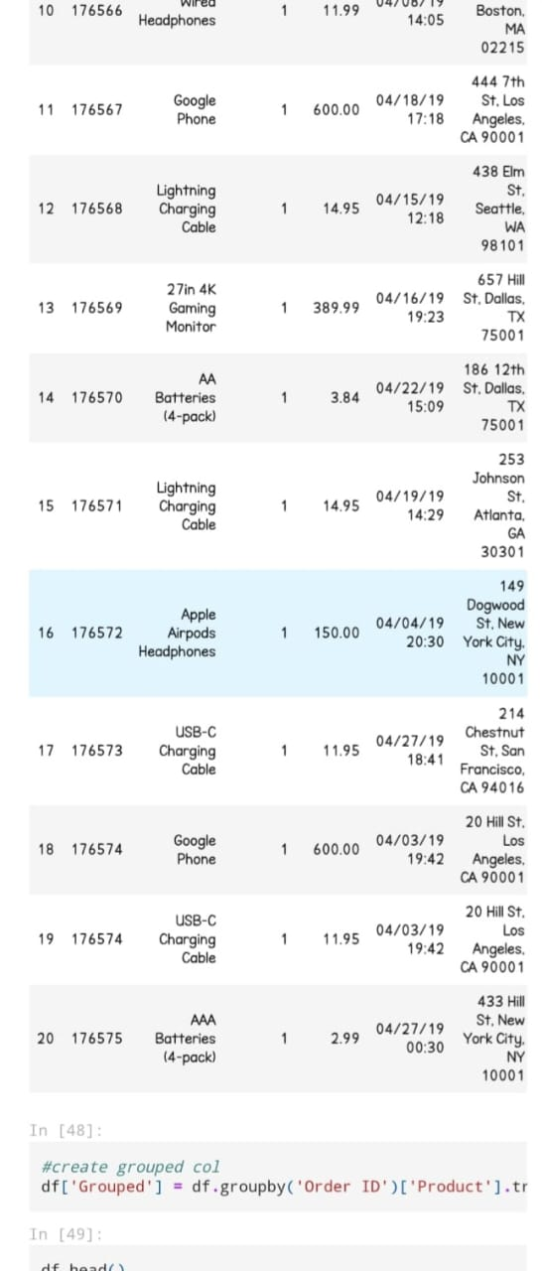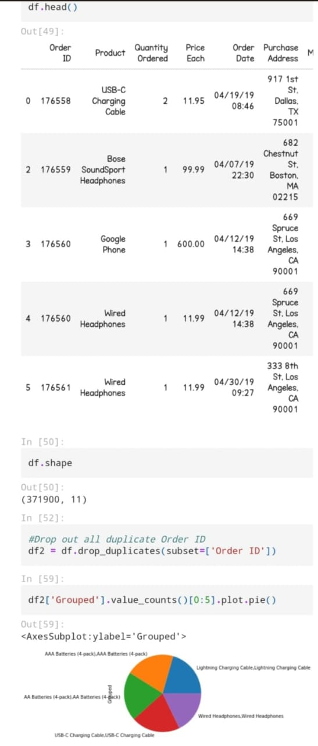**CHAPTER 7**

**Challenges in E-Commerce Sales**

### 7.1 Competition and Market Saturation:The e-commerce industry is highly competitive and increasingly saturated, posing significant challenges for businesses trying to attract and retain customers. With the rise of digital transformation, nearly every retailer now operates an online store, and many new brands emerge daily, intensifying competition across all product categories.

**Intense Competition**: E-commerce giants like Amazon, Alibaba, and Walmart dominate the market, creating challenges for smaller retailers. These large platforms can leverage economies of scale, advanced logistics, and vast resources to provide a seamless customer experience at lower prices, making it difficult for smaller businesses to compete on price and convenience. Additionally, the extensive product range and personalized recommendations offered by these companies make them a one-stop-shop for many consumers, reducing the need to browse other sites.

**7.2 Supply Chain and Logistics Issues:** Analyzes challenges in fulfilling e-commerce orders, including inventory management, shipping delays, and returns.

**7.3 Fraud Prevention and Cybersecurity:** Looks at risks related to online fraud and the measures e-commerce companies take to protect their customers.

**7.4 Customer Retention and Loyalty Programs:** Discusses strategies for retaining customers, such as loyalty programs, personalized offers, and post-purchase engagemen**t.**

**7.5 Regulatory and Legal Challenges:** Highlights regulatory hurdles, such as data privacy laws (e.g., GDPR), taxes, and international trade regulations that affect e-commerce.

**CHAPTER 8**

**Case Studies and Industry Examples**

.

### 8.1 Case Study 1: Growth of Amazon and its Strategies:Amazon’s growth story is a hallmark of e-commerce success, rooted in innovative strategies, operational efficiency, and relentless customer focus. Founded in 1994 as an online bookstore, Amazon expanded rapidly, evolving into one of the largest e-commerce platforms globally, with a presence in nearly every product category. Its success stems from several key strategies and innovations.

### 8.2 Case Study 2: Niche E-Commerce Success Stories:In contrast to giants like Amazon, some smaller e-commerce brands have found success by focusing on specific niches and tailoring their offerings to meet unique consumer needs. These niche e-commerce brands often attract a loyal customer base by offering specialized products and personalized experiences. Here are some notable examples of niche e-commerce success:

### 8.3 Case Study 3: E-Commerce Performance during the COVID-19 Pandemic:The COVID-19 pandemic had a transformative impact on e-commerce, driving unprecedented growth and accelerating digital adoption across the globe. With lockdowns, social distancing measures, and physical store closures, consumers turned to online shopping for essential goods, entertainment, and more. This shift created both opportunities and challenges for e-commerce businesses.

**Surge in Demand**: E-commerce platforms experienced a sharp increase in demand as consumers avoided in-store shopping. Categories like groceries, health products, home goods, and entertainment saw particularly high growth. For instance, companies like Amazon and Walmart reported record sales, especially for essential items and home-related products. Businesses that were prepared with strong digital infrastructure managed to adapt quickly, meeting consumer demand and benefiting from the shift.

**CHAPTER 9**

**Results and Discussion**

### 9.1 Key Findings from the Data Analysis:This section presents the main insights derived from analyzing e-commerce sales data, focusing on metrics such as overall growth rates, peak sales periods, and top-performing product categories. The key findings may include:

### 9.2 Interpretation of Sales Trends and Patterns:This section interprets the significance of the observed trends, examining the factors behind these patterns and their implications for e-commerce businesses. Here’s a deeper look:

**Rising Demand and Digital Adoption**: The continued growth in e-commerce sales is often driven by broader shifts toward digital adoption. More consumers, especially in emerging markets, are gaining access to the internet and smartphones, making e-commerce more accessible. The pandemic, as noted, accelerated this trend by increasing reliance on online shopping for essentials, suggesting that digital convenience and safety will continue to fuel e-commerce growth.

**9.3 Implications for E-Commerce Businesses:** Discusses the practical implications of the findings for businesses, such as strategies for boosting sales.

**9.4 Limitations and Areas for Future Research:** Reflects on any limitations of the study and suggests areas for future investigation.

**CHAPTER 10**

**Recommendations**

### 10.1 Optimizing Sales and Conversion Rates:This section offers practical strategies for businesses to increase sales and boost conversion rates based on insights gained from data analysis. Key recommendations might include:

**Personalized Marketing:** Implementing AI-driven recommendations and targeted email campaigns can significantly enhance conversion rates. Personalizing product suggestions, promotions, and email content based on browsing history and past purchases helps businesses engage customers more effectively and encourages repeat purchases.

### 10.2 Enhancing Customer Experience and Engagement:Improving customer experience and engagement is key to building long-term loyalty and ensuring a steady stream of repeat customers. Recommendations include:

**Customer Support and Chatbots:** Offering accessible, responsive customer support via chatbots, live chat, or social media channels helps customers resolve issues quickly. Chatbots can handle common inquiries, such as order status or product information, 24/7, while live agents address more complex questions. Providing seamless support builds trust and helps improve the post-purchase experience.

**10.3 Adapting to Technological Innovations:** Recommendations for businesses to stay ahead of technological trends that could affect e-commerce.

**10.4 Effective Use of Data Analytics and Forecasting:**How businesses can leverage data analytics to predict sales trends and make informed decisions.

**10.5 Strategic Marketing and Personalization:**strategsOfferies for improving marketing and tailoring offers to meet customer preferences.

**CHAPTER 11**

**Conclusion**

**11.1 Summary of Key Insights:**A concise summary of the main findings from the study**.**

**11.2 Conclusion on E-Commerce Sales Trends:** A final conclusion on the key trends observed in the e-commerce market.

**11.3 Final Thoughts and Future Outlook:**Concluding thoughts on the future of e-commerce and any predictions or recommendations for businesses.

**11.4 Git HubLinkof theProject:**SharetheGitHublink

https://github.com/amarnath01614/Amarnath.A.git

**References**

**1Sunil Gupta**

Works on e-commerce strategies, digital marketing, and customer analytics. His book "Driving Digital Strategy: A Guide to Reimagining Your Business" is widely referenced for understanding digital transformation in business.

**2Eric Siegel**

Author of "Predictive Analytics: The Power to Predict Who Will Click, Buy, Lie, or Die". He covers predictive modeling and analytics, particularly focusing on customer behavior prediction and churn analysis.

**3Avinash Kaushik**

Renowned for web analytics and digital marketing optimization. His book "Web Analytics 2.0" explores data analysis methods that are especially relevant for e-commerce businesses.

**4 Jeffrey D. Camm, James J. Cochran, Michael J. Fry, Jeffrey W. Ohlmann, and David R. Anderson**

Authors of "Data Analytics for Business", which is a comprehensive guide on data analytics for business applications, including predictive modeling, customer segmentation, and decision analysis.

**5Philippe Furrer and Uwe Viehmann**

Authored works on consumer behavior and e-commerce data analysis, especially from a European market perspective. Their work explores cross-cultural aspects of e-commerce and multichannel sales.

**6Randy S. Collica**

Known for contributions to customer segmentation, especially using SAS. His book "CRM Segmentation and Clustering Using SAS" is a key resource for customer analytics in e-commerce.